string attempt;

attempt = My_Dialogs.InputBox("Enter your password");

while (attempt != "basic")

{

MessageBox.Show("Wrong! - try again.");

attempt = InputBox("Enter your password");

}

MessageBox.Show("Welcome to the program!");

The first line of code is defining the variable, in this case it’s called “attempt”. It seems to be a global variable as it is not nested within code.

The second line is writing what the variable does and what its functionality is. “My_Dialogs.InputBox” is calling a solution which has already been created and imported into the current application. It causes a pop up which demands user inputted information. The second part “(“Enter your password”)” is what the input box will display, it is what will give the user their instructions.

The following line tells the application that it is a loop, meaning that the same piece of code will be repeated until; in this case, the correct password is entered. However it does not have to be a password, it will continue this until the demands of the code have been met. The “!=” is a c# operator which returns false when its operands are equal, this means that when the password matches with what would presumably be on a server. The loop will end.

The fourth line down simply pops up a message box to the user informing them that the password they tried was not successful. Following this another input box will pop up, again prompting the user to enter their password.

The final line of code is only reached if the demands of the operator/loop functions are met, if they are the user will get a pop up box which says “Welcome to the program!”. Informing them that they have successfully logged in.

Each line of code ends in a semi colon. This is because having a semi colon at the end of each line terminates that piece of code from being executed again and is used to separate different commands. It stops the computer from trying to execute several commands in a row, some of which could interfere with one another. The only time in this snippet of code there is no semi colon is after the loop, this is because if there was the loop would not start or repeat, it would have been terminated before it began.

My program.

Start up. Centre of the screen, renamed the application and removed max/minimise buttons.

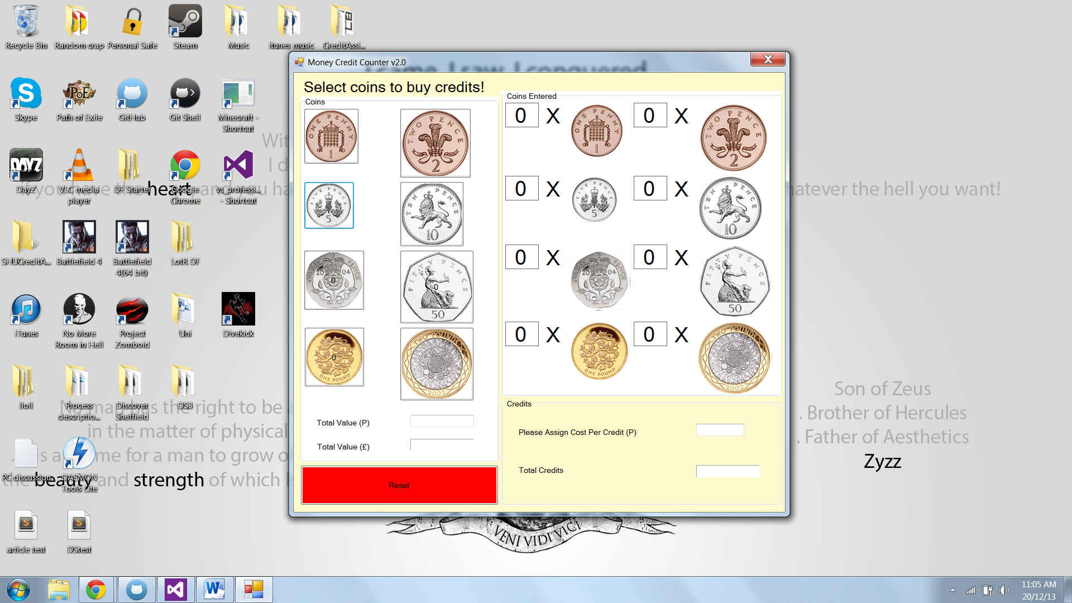

Attempting to click on one of the coins.

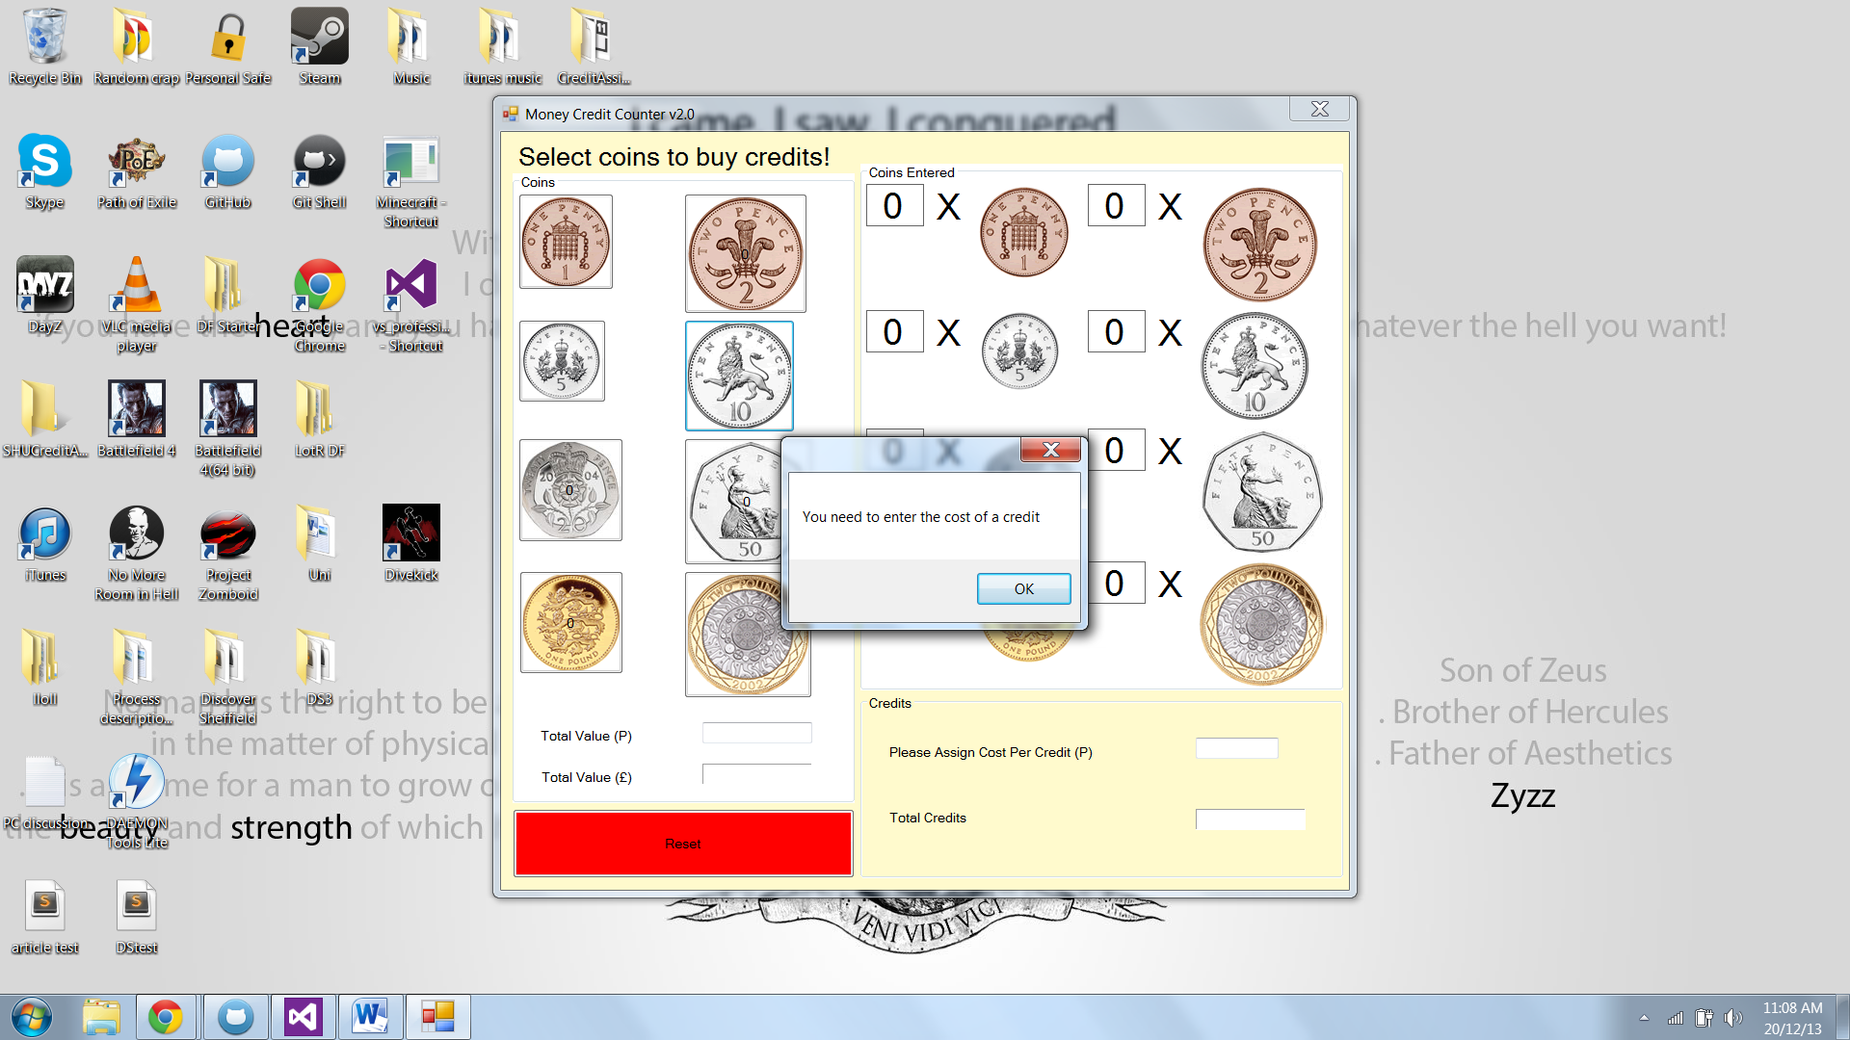

Having entered a cost of a credit. You can see that coins can be selected

